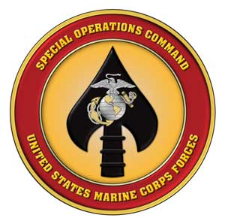

MARSOC PUBLIC AFFAIRS

PSC Box 20116, Camp Lejeune, NC 28542-0116
POC: Major Jeff Landis
jeffrey.landis@usmc.mil
(910) 440-0770

PRESS RELEASE: Marine Special Operations Command (MARSOC) conducts off-base training in Western S. C.
CAMP LEJEUNE, N.C. ( Aug. 10, 2012) — Students from the U.S. Marine Corps Forces Special Operations Command (MARSOC)’s Marine Special Operations School (MSOS), are scheduled to conduct a 20-day training exercise across a five-county area in western South Carolina near Sumter National Forest from Aug 20 to 28, 2012.
The exercise, known as “Derna Bridge,” will be conducted in or near the following counties; Richland, Sumter, Edgefield, Saluda, McCormick, Greenwood, and Abbeville which has been coordinated with public safety officials throughout the area.
Derna Bridge is a culminating event for students of the Individual Training Course after several months of intense military training conducted by the MSOS Special Operations Training Branch. The exercise is one of several conducted by the Marine Corps in conjunction with local communities. Many local residents plan to participate in portions of this training. The contribution of these volunteers adds realism during training scenarios and affords the Marines an opportunity to train for dilemmas they may encounter overseas.
Approximately 200 service members will support the exercise from various units across the military to include the South Carolina Army National Guard. These military members will provide realistic opposition forces that the students will encounter and engage.
During the course of the training some residents may hear blank gunfire or see occasional flares, which do not pose any risk to persons or property. Residents who encounter any difficulties associated with this training should contact local law enforcement officials, who will immediately contact the MSOS Exercise Control Cell.
Safety is the number-one priority for this exercise and the following safety measures have been implemented:
Formal written notification is given to the chiefs of the law enforcement agencies in the affected counties, with a personal follow up visit from a designated unit representative.
Civilian and military participants are briefed on specific procedures to follow if there is contact with non-participating civilians and law enforcement officers.
During hunting season, the instructor/staff will take additional measures to ensure the visibility and safety of participants.
Officials at MSOS appreciate the help and consideration the citizens of South Carolina extend to the Marines participating in this training. We ask for their continued understanding of any inconveniences the training may cause. Questions concerning the exercise should be referred to Maj. Jeff Landis, MARSOC Public Affairs Office at (910) 440-0770.
NOTE TO MEDIA: Request editors print this release in their paper or broadcast on their station to provide the citizens of Western South Carolina information concerning this important exercise.
-30-

