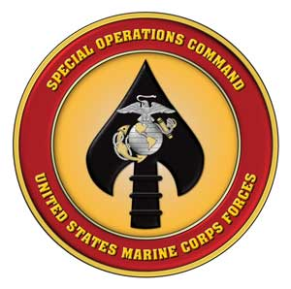
U.S MARINE CORPS FORCES SPECIAL OPERATIONS COMMAND
MARSOC Public Affairs PSC Box 20116 Camp Lejeune, NC 28542-0116

For Immediate Release Phone: 910-440-0770
RELEASE NO: A042012

MEDIA ADVISORY: MARSOC IDENTIFIES DECEASED SAILOR

MARINE CORPS BASE CAMP LEJEUNE N.C. (April 24, 2012) -- Hospital Corpsman 1st Class Matthew A. Zimmerman, 32, of Dover, Pa., died April 20 at approximately 11 p.m. at his residence in Newport, N.C., as a result of an apparent suicide. Zimmerman was assigned to 3d Marine Special Operations Battalion, U.S. Marine Corps Forces Special Operations Command.

The incident remains under investigation.

Zimmerman joined the Navy in October 2003, and was trained as a Hospital Corpsman. He served at Bethesda National Naval Medical Center, aboard USNS Comfort for three years where he participated in several humanitarian and disaster relief operations, and was later assigned to the Surface Warfare Medical Institute. He graduated the institute as an Independent Duty Corpsman with honors as well as the Preventive Medicine Course with honors. He was assigned to the Field Medical Training Battalion in September 2011 for additional training and then reported to MARSOC in late December 2011. He was promoted to Petty Officer 1st Class on Dec. 1, 2007, and his personal decorations include a Navy-Marine Corps Commendation Medal and two Good Conduct Medals.

Media with questions about this release can contact MARSOC public affairs at (910) 440-0770 or after hours at (910) 650-8472.

-30-

